**CSC 5750 – Principles of Web Technology**

**Homework 2 – [your name]**

**25 points – Due October 3, 6pm**

**Late deadline is October 5, 11:59pm, but 20% off**

**a)** Save this document with your name and the homework number somewhere in the file name.

**b)** Type/paste your answers into the document.

**c)** Gather the following files into a ZIP file:

● This document

● Main page (.HTML)

● Tourist page (.HTML)

● Map page (.HTML)

● CSS file (.CSS)

● Image files

● Any other optional files specific to your implementation

**d)** Submit the ZIP file to the Blackboard item where you downloaded this document.

You've been hired by a city to create a web site that has the following three web pages:

● A **Main page** that contains general information about the city. This may include its location, year founded, population, land area, elevation, time zone, mayor, flag, etc. Include two or more images (not including the flag).

● A **Tourist page** that lists things to do or places to see in the city. Include two or more images.

● A **Map page** that marks the city on a map. This could be a Google map with an arrow pointing to the city.

Pick any city to feature. When creating the pages, begin with the provided HTML templates (main and other). Place a header with page title(s) at the top of each page. Place a footer with city name at the bottom of each page. Incorporate the following HTML elements on each page:

● Comments.

● Paragraphs.

● At least two of the six pre-defined heading styles.

● Links to the other two pages in a menu.

● Horizontal ruler(s).

● Within the Main page, a multi-column paragraph.

● Within the Tourist page, one or more unordered lists, and an e-mail link.

Place all styling attributes in a CSS file and connect it to the three HTML pages. Include the following properties in the CSS file:

● Font properties

● Text properties

● Color properties

● Background properties

● At least three .class styles.

● At least one :hover style.

**Main page**

**<!DOCTYPE html>**

**<!--==================================================================**

**//**

**// Web site: Akihabara showcase**

**// Web page: main.html**

**// Course: CSC 5750**

**// Homework: 2**

**// Author: Caleb Latimer**

**// Date: 09/27**

**// Description: Landing page of city website, aims to provide simple context of information for the user**

**//**

**//=================================================================-->**

**<html lang='en'>**

**<head>**

**<title>Akihabara: The Tech District</title>**

**<meta name="viewport" content="width=device-width,initial-scale=1.0">**

**<meta charset="UTF-8">**

**<link rel='stylesheet' type='text/css' href='styles/font-awesome-4.7.0/css/font-awesome.min.css' />**

**<link rel='stylesheet' type='text/css' href='styles/pure-release-1.0.0/pure-min.css' />**

**<link rel='stylesheet' type='text/css' href='styles/core.css'/>**

**<link rel='icon' type='img/png' sizes='16x16' href='styles/img/customFavicon/favicon-16x16.png'/>**

**<script type='text/javascript' src='javascript/jquery-3.2.1.min.js'></script>**

**<script type='text/javascript' src='javascript/script.js'></script>**

**</head>**

**<body onload="loadMain()">**

**<header class='pure-g'>**

**<h1 class='pure-u-5-5'>Akihabara</h1>**

**<h2 class='pure-u-5-5'>Every gamers paradiso</h2>**

**</header>**

**<nav class='pure-button-group' role='group' aria-label='nav-buttons'>**

**<button class='pure-button main-button'>**

**<i class="fa fa-book" aria-hidden="true"></i>**

**Main**

**</button>**

**<button class='pure-button tourist-button'>**

**<img src='styles/img/x-run.gif' width='16' />**

**Tourist**

**</button>**

**<button class='pure-button map-button'>**

**<i class="fa fa-map-o" aria-hidden="true"></i>**

**Map**

**</button>**

**<hr />**

**</nav>**

**<main>**

**<article class='top-content'>**

**<div class='pure-g'>**

**<h2 class='pure-u-5-5'>General</h2>**

**<p class='pure-u-5-5'>Welcome to electric town!</p>**

**<strong class='pure-u-5-5'>A brief summary</strong>**

**</div>**

**<div class='pure-g'>**

**<p class=' pure-u-5-5 multi-col'>The name Akihabara is a shortening of Akibagahara (秋葉が原, "autumn leaf field"), which ultimately comes from Akiba (秋葉), named after a fire-controlling deity of a firefighting shrine built after the area was destroyed by a fire in 1869. Post WWIII the town earned itself the name of Denki Gai (Electric Town) as it exploded on the economic scene as a source of literally any and everything. In present day, Akihabara is considered to be an Otaku hotspot as it is a world famous shopping district for video games, anime, manga, and various other forms of technology.</p>**

**</div>**

**</article>**

**<hr />**

**<article class='mid-content'>**

**<div class='pure-g'>**

**<h2 class='pure-u-5-5'>Cool History</h2>**

**<p class='pure-u-5-5'>Akihabara is located in the Chiyoda ward of Tokyo,Japan.</p>**

**<p class='pure-u-5-5'>Most of the major shops specializing in manga, anime, and electronics are located just west of the Akihabara Station.</p>**

**<strong class='pure-u-5-5'>History</strong>**

**</div>**

**<div class='pure-g'>**

**<p class='pure-u-5-5'>Akihabara used to be near the Edo gate and serve as a transportation passage from the city and the rest of northwest Japan.</p>**

**<p class='pure-u-5-5'>Back then the region was home to:</p>**

**<ul class='pure-u-5-5'>**

**<li>Craftsmen</li>**

**<li>Tradesman</li>**

**<li>Low class samurai</li>**

**</ul>**

**<p class='pure-u-5-5'>The city was burned to the ground in 1869 as the result of one of the frequent Tokyo fires which were a big problem back then. As a direct result of the fire, a shrine called Chinkasha and later called Akiba shrine was built to replace the buildings and as a show of major effort to prevent future fires.</p>**

**<p class='pure-u-5-5'>In 1888 the station was built so the shrine got moved to Taito ward where it stands today as a monument of history. Post-1890, Akihabara station becamea major freight point for the district. Specializing in the produce market, then in 1930s began to focus more on household electronics which is what started the nickname of Electric Town.</p>**

**<p class='pure-u-5-5'>As household electronics began to lose their futuristic appeal in the 80s the shops began to focus more on computers. With the introduction of computers as a hobbyist pass time and shops turning to tailor towards that subculture it brought about the Otaku specialization.</p>**

**<p class='pure-u-5-5'>As time went on this computer otaku customer base changed the culture of Akihabara to reflect their popular interests such as anime,manga and video games. As it stands today Akihabara is a worldwide epicenter for Otaku culture and is even regarded as a special place in most popular series.</p>**

**</div>**

**</article>**

**<hr />**

**<article class='bot-content'>**

**<div class='pure-g'>**

**<h2 class='pure-u-5-5'>Want to learn more?</h2>**

**<p class='pure-u-5-5'>Check out the following details</p>**

**</div>**

**<dl>**

**<div class='pure-g info-grid'>**

**<div class='pure-u-1-3'>**

**<div class='ex-history'>**

**<dt>History<img src='styles/img/book.jpg' class='pure-img'/></dt>**

**<dd class='text-special'>**

**Founded in: The Edo era of Japanese History officially in 1603.<br/>**

**Population in 2017: Approx 127,368,088**

**</dd>**

**</div>**

**</div>**

**<div class='pure-u-1-3'>**

**<div class='geo'>**

**<dt><p class='pure-u-5-5'>Geography</p> <img src='styles/img/geo.jpg' class='pure-img'/></dt>**

**<dd class='text-special'>**

**Land area: 377,915 km<sup>2</sup><br/>**

**Altitude: 21m<br/>**

**Time Zone: Asia/Tokyo<br/>**

**Climate: 60&#8457;-94&#8457;(Hot) 26&#8457;-67&#8457;(Cold)<br/>**

**Latitude: 35.3872&#176;<br/>**

**Longitude: 139.4378&#176;**

**</dd>**

**</div>**

**</div>**

**<div class='pure-u-1-3'>**

**<div class='pol'>**

**<dt>Politics<img src='styles/img/politics.png' class='pure-img'/></dt>**

**<dd class='text-special'>**

**Mayor:Masami Ishikawa<br/>**

**Ward: Chiyoda District<br/>**

**District Flag:<img src='styles/img/chiyoda.png' class='pure-img'/>**

**</dd>**

**</div>**

**</div>**

**</div>**

**</dl>**

**</article>**

**</main>**

**<footer>**

**<small><b>Disclaimer: </b>Information shown here is not thoroughly researched, or fact-checked. There may be inaccuracies.</small><br/>**

**<small><b>Copyright</b> &copy; Akihabara District <img src='styles/img/favicon.ico' /> Changing Lives: 1-bit per byte per bite</small><br />**

**<small><b>Developed</b> by Caleb Latimer</small><br />**

**<small><span id='mail'><a href="mailto:latimercaleb@gmail.com?subject=feedback">latimercaleb@gmail.com</a></span></small>**

**</footer>**

**</body>**

**</html>**

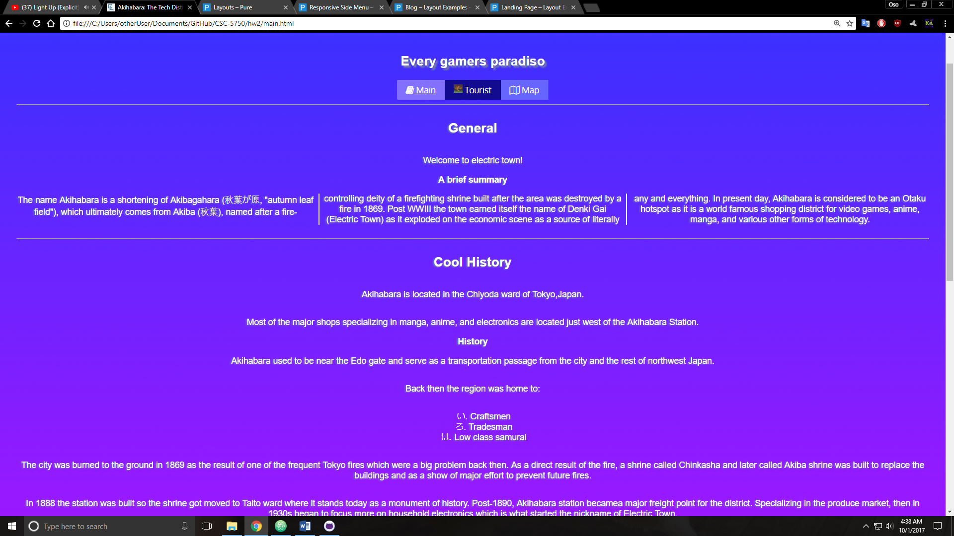

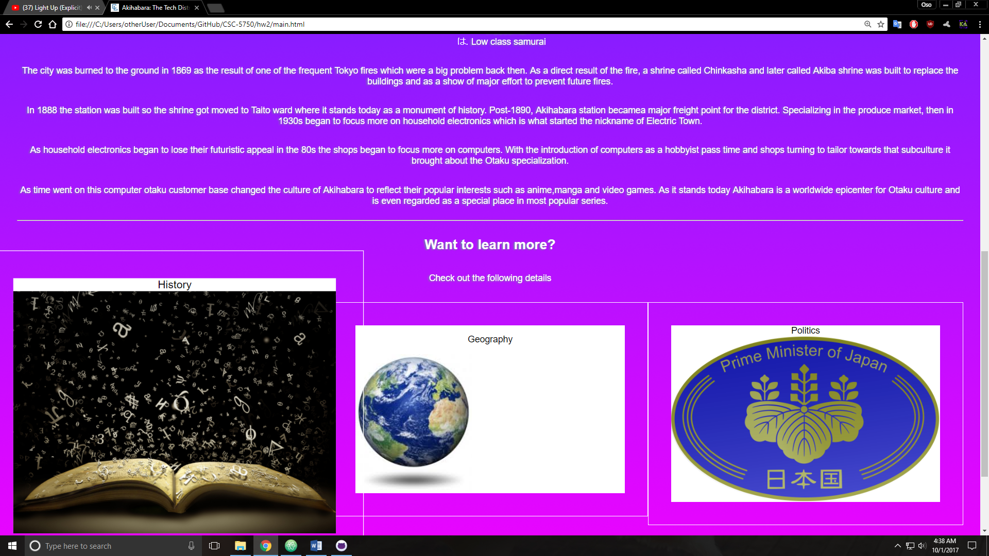

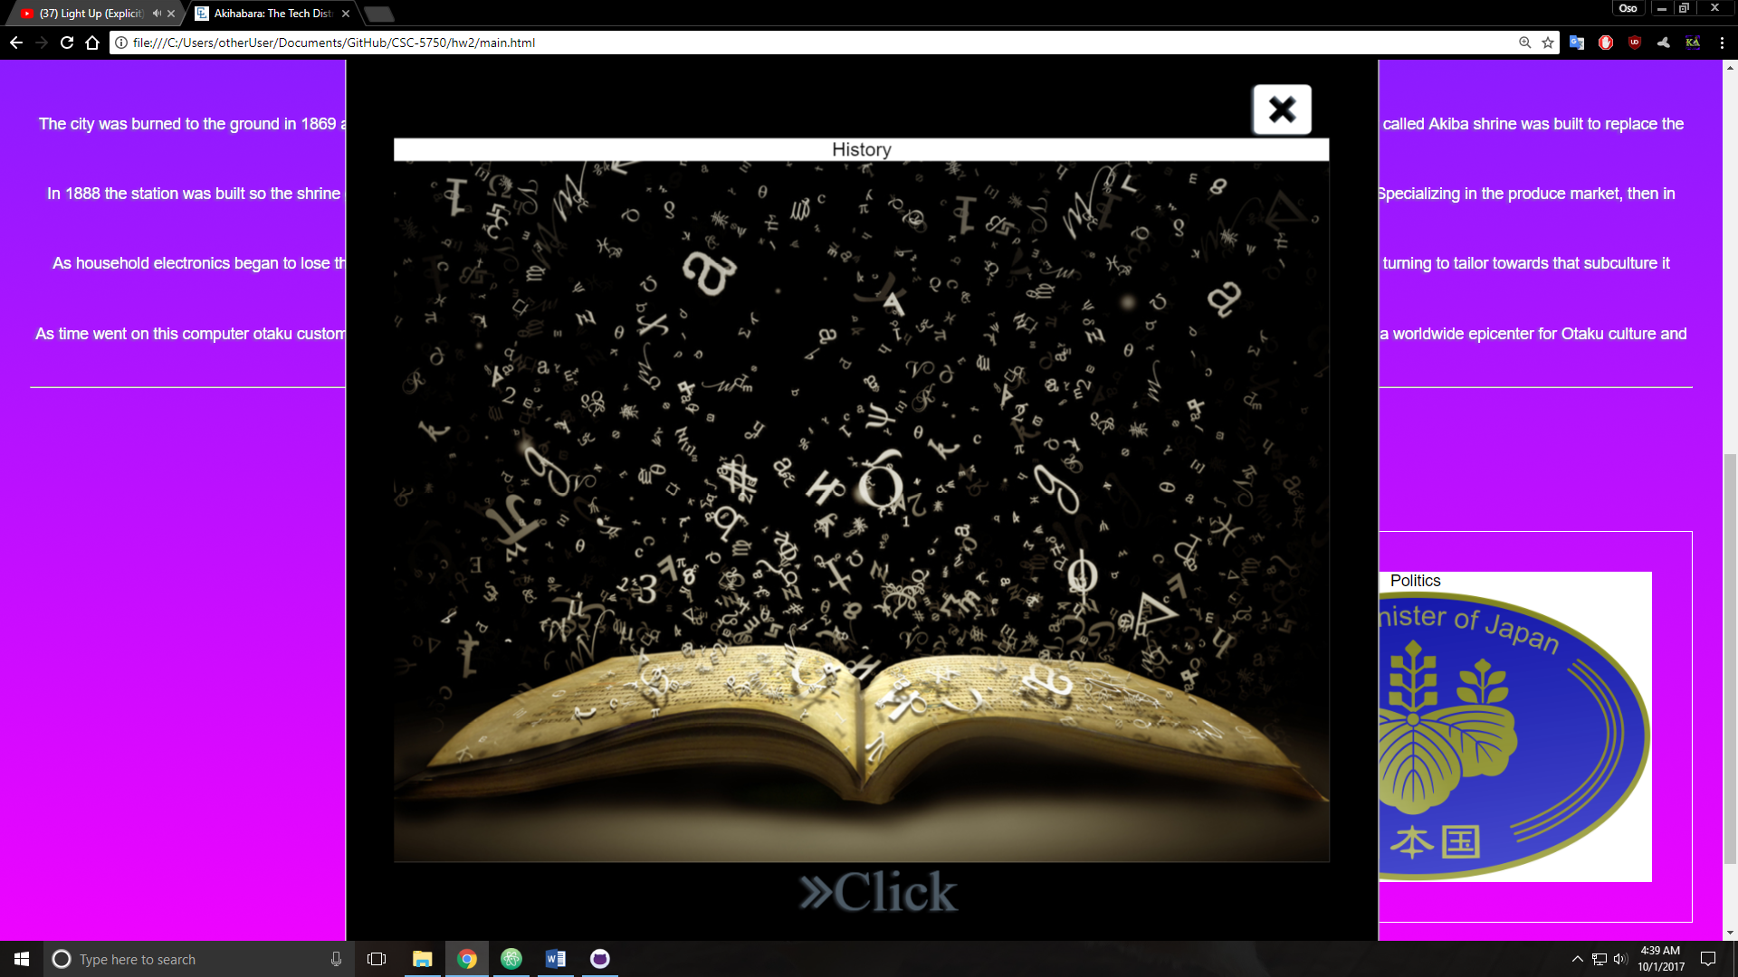

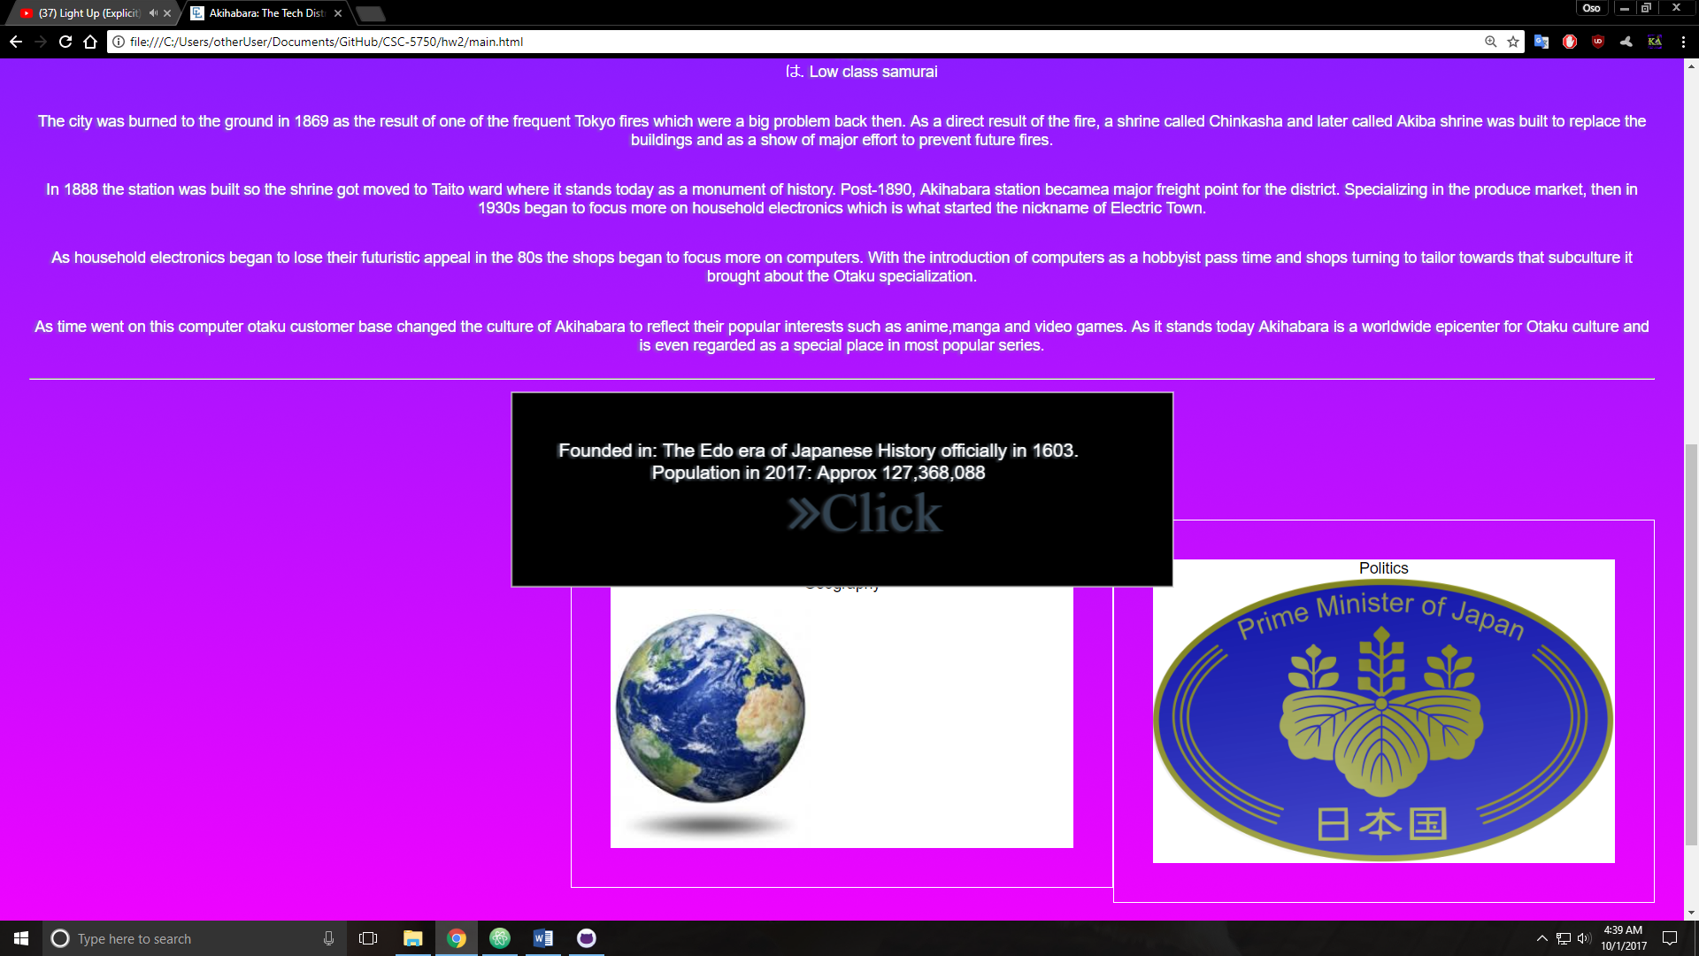

**Tourist page**

***<!DOCTYPE html>***

***<!--==================================================================***

***//***

***// Web site: Akihabara showcase***

***// Web page: tourist.html***

***// Description: Tourist page to highlight the city's strong points, and visitor attractions***

***//=================================================================-->***

***<html lang='en'>***

***<head>***

***<title>Akihabara: Tourist Attractions</title>***

***<meta name="viewport" content="width=device-width,initial-scale=1.0">***

***<meta charset="UTF-8">***

***<link rel='stylesheet' type='text/css' href='styles/font-awesome-4.7.0/css/font-awesome.min.css' />***

***<link rel='stylesheet' type='text/css' href='styles/pure-release-1.0.0/pure-min.css' />***

***<link rel='stylesheet' type = 'text/css' href='styles/core.css'/>***

***<link rel="icon" type="image/png" sizes="16x16" href="styles/img/customFavicon/favicon-16x16.png">***

***<script type='text/javascript' src='javascript/jquery-3.2.1.min.js'></script>***

***<script type='text/javascript' src='javascript/script.js'></script>***

***</head>***

***<body onload="loadTour()">***

***<header class='pure-g'>***

***<h1 class='pure-u-5-5'>Akihabara</h1>***

***<h2 class='pure-u-5-5'>Every gamers paradiso</h2>***

***</header>***

***<nav class='pure-button-group' role='group' aria-label='nav-buttons'>***

***<button class='pure-button main-button'>***

***<i class="fa fa-book" aria-hidden="true"></i>***

***Main***

***</button>***

***<button class='pure-button tourist-button'>***

***<img src='styles/img/x-run.gif' width='16' />***

***Tourist***

***</button>***

***<button class='pure-button map-button'>***

***<i class="fa fa-map-o" aria-hidden="true"></i>***

***Map***

***</button>***

***<hr />***

***</nav>***

***<main>***

***<article class='top-content'>***

***<div class='pure-g'>***

***<h2 class='pure-u-5-5'>Awesome stuff to see</h2>***

***<p class='pure-u-5-5'>All things nerd! And some other things, let's give some highlights!</p>***

***</div>***

***<div class='pure-g'>***

***<h6 class='pure-u-5-5'>Are you a game nerd? Well welcome to a bit of heaven on earth</h6>***

***<div class='pure-u-1-2'>***

***<b class='pure-u-5-5'>Arcades</b>***

***<img src='styles/img/superPotatoIntro.jpg' class='pure-img'/> <!-- make a carousel with the other imgs -->***

***<p class='pure-u-5-5'>What is a gamer without an arcade? Check out the most critcally acclaimed arcade in existence with retro classics dating back to the 70s, with 3 floors of button mashing, combo breaking, joystick slapping madness.</p>***

***</div>***

***<div class='pure-u-1-2'>***

***<b class='pure-u-5-5'>Nintendo's Rural Culture Retreat</b>***

***<img src='styles/img/nintendoRuralIntro.jpg' />***

***<p class='pure-u-5-5'>What gamer doesn't know Nintendo? If your a 90's kid lke me then Nintendo is probably what first brought you into the world of being a gamer. So of course I'm gonna recommend you go see the newly founded in 2006 musuem funded by Nintendo near the Kyoto Prefecture. The museum isn't focused around the video game makers though, it's main feature is "Hyakunin Isshu" a poetry based card game with 100 poems. Giant tiles are spread across the floor and players aim to match poem cards before their opponent. It pays homage to history and has a super modern look and feel as the panes are full interactive and can even be manipulated remotely with customized Nintendo DS handhelds. There is also a rock garden, tons of experimental interactive game tech,and other games making it well worth the trip.</p>***

***</div>***

***</div>***

***<div class='pure-g'>***

***<h6 class='pure-u-5-5'>Okay, so maybe your not a gamer, that's fine there's still some awesome stuff to see</h6>***

***<div class='pure-u-1-3'>***

***<b class='pure-u-5-5'>Akihabara Crossfield</b>***

***<img src='styles/img/crossfield.jpg' />***

***<p>The crossfield complex has a ton of stuff in it resturants, stores, conference rooms and showcases. Going on a tour and finding some good photo-ops should make your trip well worth.</p>***

***</div>***

***<div class='pure-u-1-3'>***

***<b class='pure-u-5-5'>Cat Cafe</b>***

***<img src='styles/img/catCafeIntro.jpg' class='pure-img' />***

***<p class='pure-u-5-5'>Because who doesn't like the little kitty-witty! Grab a snack and hang with these adorable little fuzzy critters</p>***

***</div>***

***<div class='pure-u-1-3'>***

***<b class='pure-u-5-5'>Weapon Store</b>***

***<img src='styles/img/weaponsIntro.jpg' class='pure-img' />***

***<p class='pure-u-5-5'>And of course who could leave without some glorious nippon steel? Check out the weapons district for various authentic swords, armor and shuriken. Try them on, take some pics, just don't lose any fingers.</p>***

***</div>***

***</div>***

***</article>***

***<hr />***

***<article class='bot-content'>***

***<div class='pure-g'>***

***<h2 class='pure-u-5-5'>Don't just sight see, get in the game</h2>***

***<p class='pure-u-5-5'>If you're in Akihabara there's a ton to do so grab your coffee, your snacks and get ready for a long haul. Because from binging anime to internet cafes we are gonna break down the hotspots so you that you know where to be. Major stuff to do breaks down into the following 3 categories:</p>***

***<ul class='pure-u-5-5'>***

***<li>Video Game Stuff</li>***

***<li>Computer Stuff</li>***

***<li>Otaku Stuff</li>***

***</ul>***

***<p class='pure-u-5-5'>Now before you start, yes <i>technically</i> all of the above are <b>Otaku</b> types of hobbies but no two snowflakes are the same. These 3 main groups of hobbies have the biggest range of shops and centers catering to that group. So looking at this objectively limiting our scope in a simple manner helps solve the TSP(traveling salesman problem) or in this case. The TOP(traveling otaku problem)</p>***

***</div>***

***<div class='pure-g'>***

***<h6 class='pure-u-5-5'>Hope you brought your wallet</h6>***

***<div class='pure-u-1-3'>***

***<b class='pure-u-5-5'>Gamers</b>***

***<img src='styles/img/gamers.jpg' />***

***<p class='pure-u-5-5'>Gamers sells a wide range of anime and manga related goods including movies, video games, CDs, stationery, software and character goods.</p>***

***</div>***

***<div class='pure-u-1-3'>***

***<b class='pure-u-5-5'>Shooting Bar EA</b>***

***<img src='styles/img/shooting-bar.jpg' class='pure-img'/>***

***<p class='pure-u-5-5'>Shooting Bar EA is a BB gun target range and bar ... yup, drink up, and shoot things! Once you've signed the obligatory rules and regs contract and ventured inside, the bar and cosy tables are surrounded by BB gun replicas hanging on the walls – Glocks, Sig Sauers, Colts, and even a Samurai Edge, the handgun used in the Resident Evil video games. The partitioned shooting range is outfitted with a touch panel to control the targets' location, and guns with three magazines of BBs or rifles with two are available to rent. Goggles are provided. So check it out!</p>***

***</div>***

***<div class='pure-u-1-3'>***

***<b class='pure-u-5-5'>Hey!</b>***

***<img src='styles/img/hey.jpg' class='pure-img'/>***

***<p class='pure-u-5-5'>Feeling competitive? Short for Hirose Entertainment Yard, Hey! is a must-stop in Akihabara for arcade game lovers. Rows and rows of arcade machines flicker under the fluorescent lights, and you'll need guts of steel and quick reflexes on the arcade's second floor, dedicated to crazy "bullet hell" shoot-'em-up games like Mushihimesama, in which endless streams of projectiles are fired at players. The third floor is filled with fighting games, and the regulars are some of the best gamers in Japan. Hey! isn't where people go to practice. It's where they go to show off.</p>***

***</div>***

***</div>***

***<div class='pure-g'>***

***<h6 class='pure-u-5-5'>Hope you remember how far you have to carry all this stuff</h6>***

***<div class='pure-u-1-3'>***

***<b class='pure-u-5-5'>Yodobashi Camera: The Leisure Hive</b>***

***<img src='styles/img/yodobashi.JPG' class='pure-img' />***

***<p class='pure-u-5-5'>Ground Zero for tech-heads everywhere. Any gadget, mobile tech, camera, computer can be found in this massive 9 floor retail center. Complete with standard and internet cafes within.</p>***

***</div>***

***<div class='pure-u-2-3'>***

***<b class='pure-u-5-5'>Tsukimo Robot Kingdom</b>***

***<img src='styles/img/roboIntro.jpg'/>***

***<p class='pure-u-5-5'>What's a computer adventure without robots? Check out Tsukimo for all things microprocessing, robotics, DIY drone tech and all beeping and booping goodness!</p>***

***</div>***

***</div>***

***<div class='pure-g'>***

***<h6 class='pure-u-5-5'>Hope you brought your backpack</h6>***

***<div class='pure-u-1-3'>***

***<b class='pure-u-5-5'>Mandarake</b>***

***<img src='styles/img/mandarake.jpg' />***

***<p class='pure-u-5-5'>Mandarake, the self described <b>largest manga and anime shop in the world</b>, operates a large branch in Akihabara. Specializing in pre-owned goods, it is a good place to find rare and collectible manga, figurines, dolls, posters, CDs, toys and other types of manga related goods.</p>***

***</div>***

***<div class='pure-u-1-3'>***

***<b class='pure-u-5-5'>Gundam Cafe</b>***

***<img src='styles/img/gundam.jpg' />***

***<p class='pure-u-5-5'>The Gundam Cafe is themed after the extremely popular Mobile Suit Gundam anime series. The cafe serves gundam themed dishes and is decorated with art and themes from the series. A gift shop is attached and sells character goods and souvenirs.</p>***

***</div>***

***<div class='pure-u-1-3'>***

***<b class='pure-u-5-5'>Cure Maid Cafe</b>***

***<img src='styles/img/maidCafeIntro.jpg' class='pure-img'/>***

***<p class='pure-u-5-5'>It’s said to be the first Maid cafe ever open in Akihabara as well as all over Japan. Cure Maid Cafe has its own very old style, make you feel like you are enjoying a tea time party in Victorian Era. The menu, which also has slight European taste, with seasonal changes and weekly special dishes. One of the best thing here is the variety of the tea and desserts, you should definitely try the Earl Grey tea!</p>***

***</div>***

***</div>***

***</article>***

***<hr />***

***</main>***

***<footer>***

***<small><b>Disclaimer: </b>Information shown here is not thoroughly researched, or fact-checked. There may be inaccuracies.</small><br/>***

***<small><b>Copyright</b> &copy; Akihabara District <img src='styles/img/favicon.ico' /> Changing Lives: 1-bit per byte per bite</small><br />***

***<small><b>Developed</b> by Caleb Latimer</small><br />***

***<small><span id='mail'><a href="mailto:latimercaleb@gmail.com?subject=feedback">latimercaleb@gmail.com</a></span></small>***

***</footer>***

***</body>***

***</html>***

**If possible, format your code like this:**

**Font “Courier New”**

**Font size “9”**

**Bold**

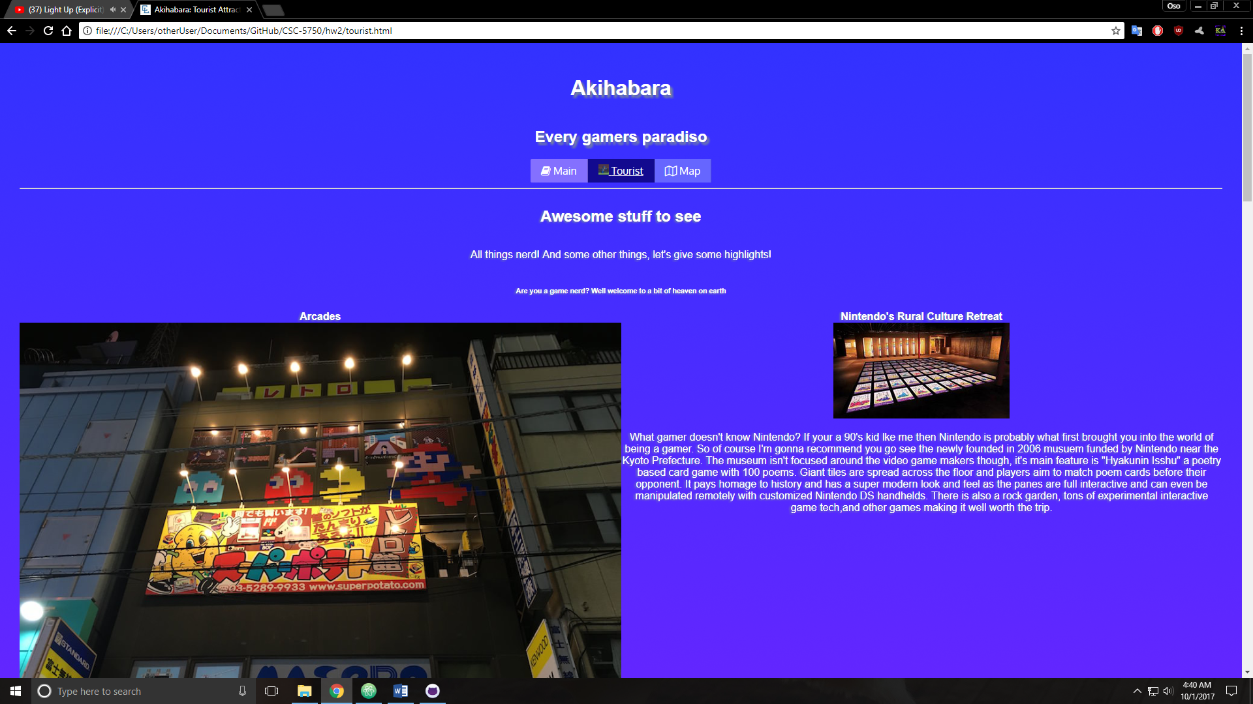

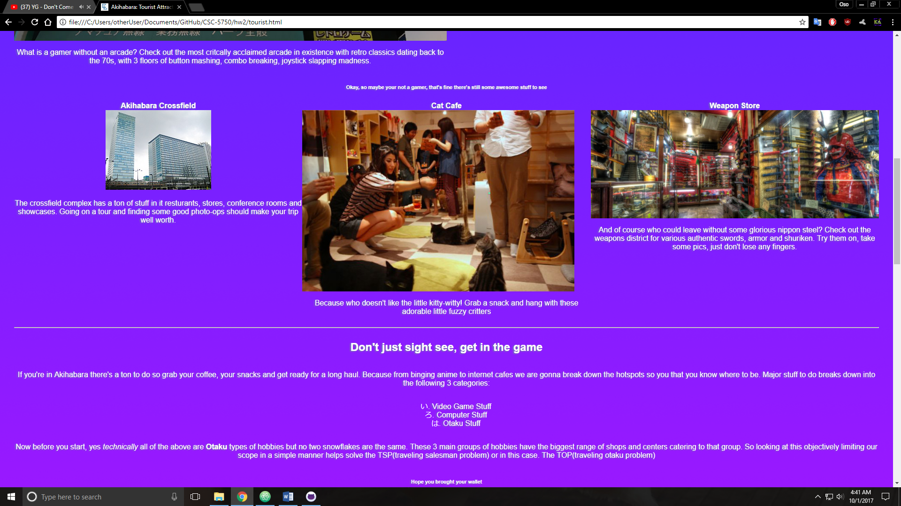

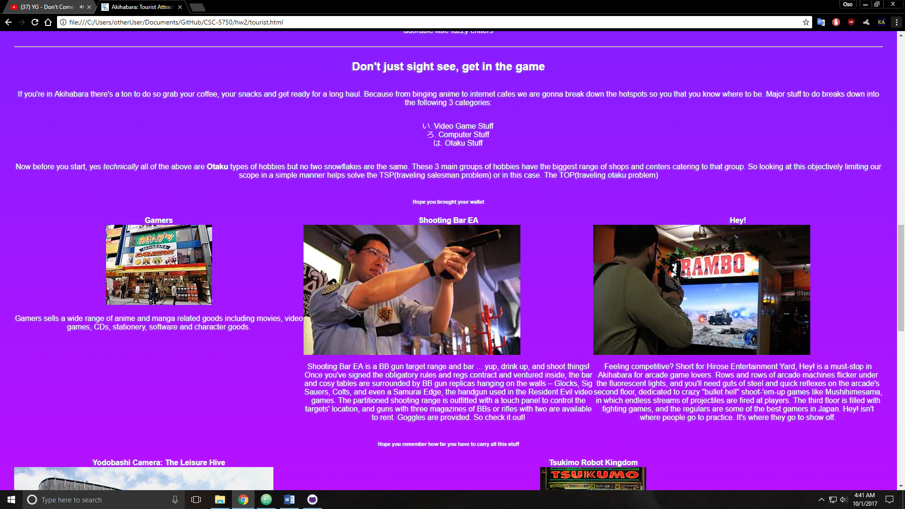

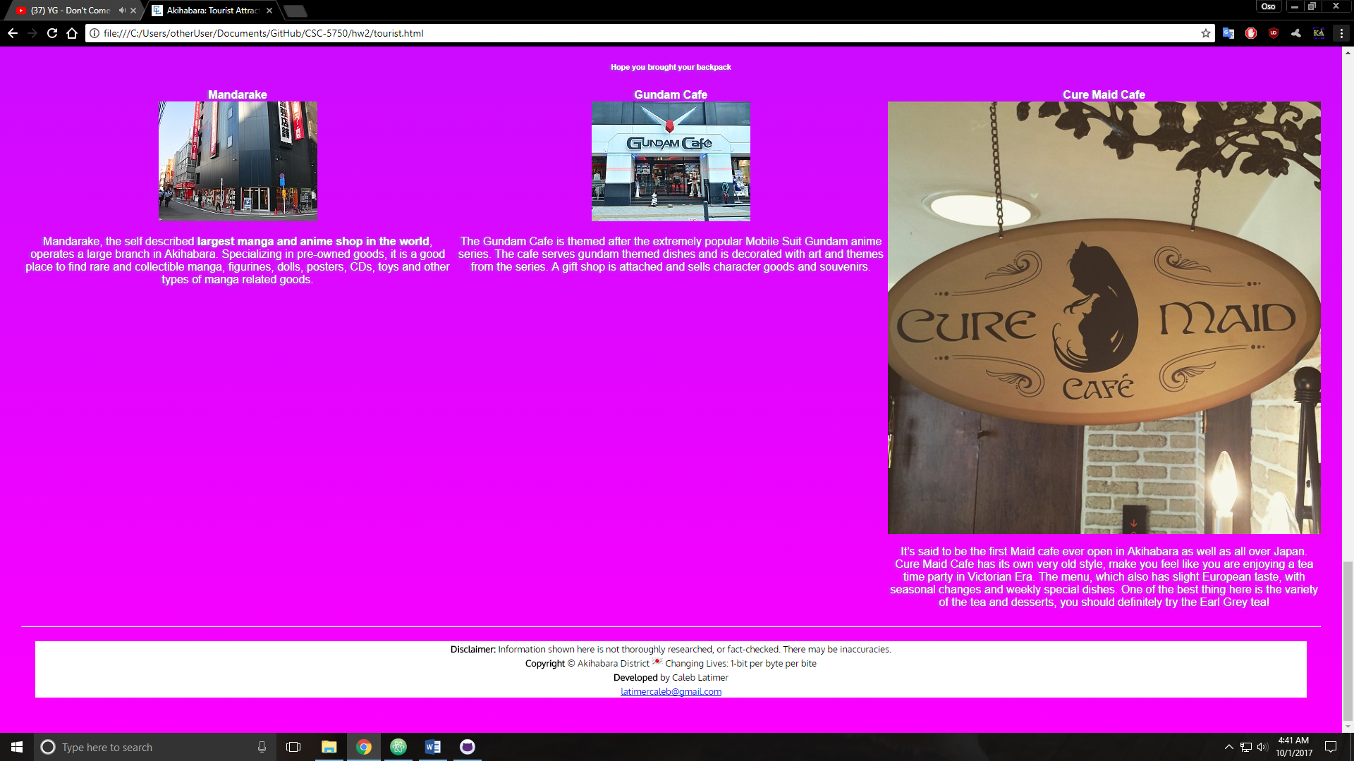

**Map page**

***<!DOCTYPE html>***

***<!--==================================================================***

***//***

***// Web site: Akihabara showcase***

***// Web page: map.html***

***// Description: Map to where the city is, making use of google api plugin***

***//=================================================================-->***

***<html lang='en'>***

***<head>***

***<title>Akihabara: Map</title>***

***<meta name="viewport" content="width=device-width,initial-scale=1.0">***

***<meta charset="UTF-8">***

***<link rel='stylesheet' type='text/css' href='styles/font-awesome-4.7.0/css/font-awesome.min.css' />***

***<link rel='stylesheet' type='text/css' href='styles/pure-release-1.0.0/pure-min.css' />***

***<link rel='stylesheet' type = 'text/css' href='styles/core.css'/>***

***<link rel="icon" type="image/png" sizes="16x16" href="styles/img/customFavicon/favicon-16x16.png">***

***<script type='text/javascript' src='javascript/jquery-3.2.1.min.js'></script>***

***<script type='text/javascript' src='javascript/script.js'></script>***

***<body onload="loadMap()">***

***<header class='pure-g'>***

***<h1 class='pure-u-5-5'>Akihabara</h1>***

***<h2 class='pure-u-5-5'>Every gamers paradiso</h2>***

***</header>***

***<nav class='pure-button-group' role='group' aria-label='nav-buttons'>***

***<button class='pure-button main-button'>***

***<i class="fa fa-book" aria-hidden="true"></i>***

***Main***

***</button>***

***<button class='pure-button tourist-button'>***

***<img src='styles/img/x-run.gif' width='16' />***

***Tourist***

***</button>***

***<button class='pure-button map-button'>***

***<i class="fa fa-map-o" aria-hidden="true"></i>***

***Map***

***</button>***

***<hr />***

***</nav>***

***<main>***

***<div class='pure-g'>***

***<h3 class='pure-u-1-5'>Where is it?</h3>***

***<aside class='side-blurb pure-u-4-5'>***

***<dl>***

***<dt>Short Answer</dt>***

***<dd>It's in Japan</dd>***

***<dt>Long Answer</dt>***

***<dd>It's in Japan, in the Chiyoda ward near Taito. A stone's throw from Tokyo bay. South of Ueno. West of Sumida River and Northeast of the Chiyoda Imperial Palace. </dd>***

***</dl>***

***</aside>***

***</div>***

***<hr />***

***<article class='pure-g map-content'>***

***<iframe src="https://www.google.com/maps/embed?pb=!1m18!1m12!1m3!1d3239.9760193574853!2d139.77227026525938!3d35.702207730189436!2m3!1f0!2f0!3f0!3m2!1i1024!2i768!4f13.1!3m3!1m2!1s0x60188ea73ea6f4ff%3A0x5eb9f1e50fe061e3!2sAkihabara%2C+Taito%2C+Tokyo+110-0006%2C+Japan!5e0!3m2!1sen!2sus!4v1506641063787" class='pure-u-5-5' allowfullscreen></iframe>***

***<p class='pure-u-5-5'>Or find it on google here <a href='https://www.google.com/maps/place/Akihabara,+Taito,+Tokyo+110-0006,+Japan/@35.7022077,139.7722703,17z/data=!3m1!4b1!4m5!3m4!1s0x60188ea73ea6f4ff:0x5eb9f1e50fe061e3!8m2!3d35.7022051!4d139.7741464'>Google Maps</a></p>***

***</article>***

***<hr />***

***</main>***

***<footer>***

***<small><b>Disclaimer: </b>Information shown here is not thoroughly researched, or fact-checked. There may be inaccuracies.</small><br/>***

***<small><b>Copyright</b> &copy; Akihabara District <img src='styles/img/favicon.ico' /> Changing Lives: 1-bit per byte per bite</small><br />***

***<small><b>Developed</b> by Caleb Latimer</small><br />***

***<small><span id='mail'><a href="mailto:latimercaleb@gmail.com?subject=feedback">latimercaleb@gmail.com</a></span></small>***

***</footer>***

***</body>***

**</html>**

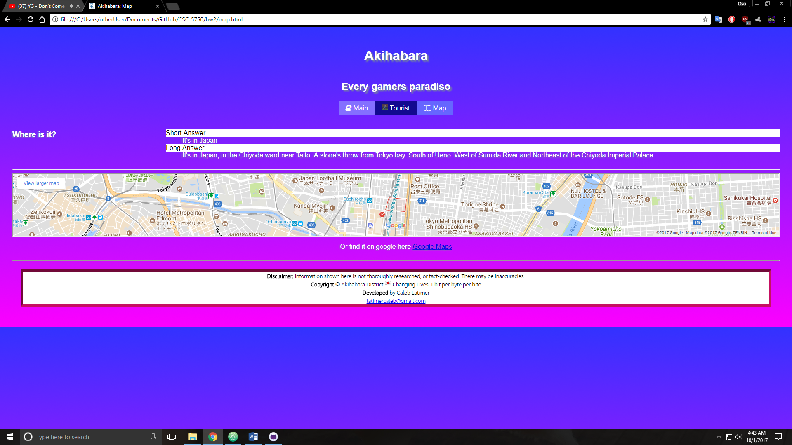

**CSS file**

***/*==========================================================***

***Title: CSS External for Akihabara Showcase***

***Description:***

***This CSS is the external styling for the akihabara showcase website, this is the core styles for the site. Individual custom styles outside of the pure-framework.***

***==========================================================*/***

***/* Custom Font from google*/***

***@import url('https://fonts.googleapis.com/css?family=Oxygen');***

***/*keyframe animation for the card icon indicating user action*/***

***@keyframes slide {***

***0% {margin-left: 0px}***

***25% {margin-left: 10px; color: #e3f2fd; opacity: 0.6;}***

***50% {margin-left: 30px; color: #bbdefb; opacity: 0.4;}***

***75% {margin-left: 60px; color: #64b5f6; opacity: 0.2;}***

***100% {margin-left: 70px; color: #e3f2fd; opacity: 0;}***

***}***

***/*Main element tags*/***

***body {***

***font-family: 'Oxygen', Helvetica, sans-serif;***

***margin: 20px;***

***padding: 10px;***

***color: #FFF;***

***background: linear-gradient(to top, #fc00ff, #3232FF);***

***}***

***header {***

***text-align: center;***

***text-shadow: 4px 4px 2px rgb(119,136,153);***

***}***

***nav {***

***text-align: center;***

***}***

***main {***

***text-shadow: -2px 1px 2px rgba(119, 136, 153, 1);***

***}***

***article,footer{***

***text-align: center;***

***}***

***footer {***

***margin: 20px;***

***color: black;***

***font-weight: 500;***

***background-color: #FFF;***

***}***

***li {***

***list-style-position: inside;***

***list-style-type: hiragana-iroha;***

***}***

***dt {***

***color: #000;***

***text-shadow: none;***

***background-color: #FFF;***

***}***

***/*Psuedo selectors styled here*/***

***\* ::selection {***

***color: black;***

***background-color: white;***

***}***

***small::selection {***

***color: white;***

***background-color: black;***

***}***

***footer:hover {***

***border: 5px inset #c51162;***

***}***

***.info-grid:hover{***

***cursor: pointer;***

***}***

***/*Classes & IDs*/***

***.card-text {***

***display: none;***

***}***

***.main-button {***

***margin: 0 2px 0 2px;***

***background-color: #8470FF;***

***color: #FFF;***

***}***

***.tourist-button {***

***margin: 0 2px 0 2px;***

***background-color: #120A8F;***

***color: #FFF;***

***}***

***.map-button {***

***margin: 0 2px 0 2px;***

***background-color: #6666FF;***

***color: #FFF;***

***}***

***.multi-col {***

***column-count: 3;***

***column-rule: 2px double #FFF;***

***}***

***.top-content {***

***text-align: center;***

***}***

***.ex-history {***

***border: 1px solid #FFF;***

***padding: 40px;***

***text-align: center;***

***}***

***.geo {***

***border: 1px solid #FFF;***

***padding: 40px;***

***text-align: center;***

***}***

***.pol {***

***border: 1px solid #FFF;***

***padding: 40px;***

***text-align: center;***

***}***

***.footer-pic {***

***float: right;***

***}***

***.text-special {***

***display: none;***

***}***

***.focused-button{***

***text-decoration: underline;***

***}***

***.big-card {***

***position: fixed;***

***top: 50%;***

***left: 50%;***

***transition-timing-function: ease-in;***

***transition-duration: 0.7s;***

***transform: translate(-50%, -50%) scale(1.2) rotateY(0deg);***

***background-color: #000;***

***}***

***.focused-card {***

***transform: translateY(-10%) scale(1.2);***

***}***

***.card-rotate {***

***transition-timing-function: ease-out;***

***transition-duration: 0.7s;***

***transform: translate(-50%, -50%) scale(1.2) rotateY(180deg) ;***

***}***

***.text-reverse {***

***transform: rotateY(180deg);***

***}***

***#moveIcon {***

***transform: translateX(45%);***

***}***

***.fa-angle-double-right {***

***animation-name: slide;***

***animation-duration: 2s;***

***animation-timing-function: ease-out;***

***animation-iteration-count: infinite;***

***}***

**Javascript file**

**/*==========================================================**

**Title: Javascript External for Akihabara Showcase**

**Description:**

**This Javascript is the external functionality for the akihabara showcase website**

**==========================================================*/**

**// nav functions**

**// nav buttons are enabled**

**function enableNav(){**

**$('.main-button').click(function(){**

**location.assign('main.html');**

**});**

**$('.tourist-button').click(function(){**

**location.assign('tourist.html');**

**});**

**$('.map-button').click(function(){**

**location.assign('map.html');**

**});**

**}**

**// Underlines the main-button if the main page is on screen**

**function loadMain() {**

**$('.main-button').addClass('focused-button');**

**$('.tourist-button').removeClass('focused-button');**

**$('.map-button').removeClass('focused-button');**

**enableNav();**

**}**

**// Underlines the load-button if the load page is on screen**

**function loadTour() {**

**$('.tourist-button').addClass('focused-button');**

**$('.main-button').removeClass('focused-button');**

**$('.map-button').removeClass('focused-button');**

**enableNav();**

**}**

**// Underlines the map-button if the map page is on screen**

**function loadMap() {**

**$('.map-button').addClass('focused-button');**

**$('.tourist-button').removeClass('focused-button');**

**$('.main-button').removeClass('focused-button');**

**enableNav();**

**}**

**// Removes the X-icon once it is clicked**

**function deleteX(){**

**$('#moveIcon').remove();**

**$('#promptIcon').remove();**

**}**

**// an event has occured so now the events are bound locally to their respective elements without event - delegation**

**function regrid(){**

**$('.ex-history').mouseenter(raiseCard);**

**$('.ex-history').mouseleave(lowerCard);**

**$('.ex-history').click(reactivateCard);**

**$('.geo').mouseenter(raiseCard);**

**$('.geo').mouseleave(lowerCard);**

**$('.geo').click(reactivateCard);**

**$('.pol').mouseenter(raiseCard);**

**$('.pol').mouseleave(lowerCard);**

**$('.pol').click(reactivateCard);**

**}**

**// callback functions**

**// Raise and scale card by a small factor**

**function raiseCard(){**

**$(this).addClass('focused-card');**

**}**

**// Return card to original state when not hovered**

**function lowerCard(){**

**$(this).removeClass('focused-card');**

**}**

**// On click, extend card to middle of screen, load x-button and remove all delegated events**

**function activateCard(){**

**$(document).off();**

**$(this).removeClass('focused-card');**

**$(this).addClass('big-card');**

**$(this).prepend("<div id='moveIcon'><i class=' fa fa-window-close fa-3x'></i></div>");**

**// new icon added at bottom to make user want to click again**

**$(this).append("<div id='promptIcon'><i class=' fa fa-angle-double-right fa-3x'>Click</i></div>");**

**// add event to new x-icon to trigger on-click**

**$('#moveIcon').click(function(e){**

**$(this.parentNode).removeClass('big-card');**

**$(this).children('dt').removeClass('text-special');**

**$(this).children('dd').addClass('text-special');**

**$(this.parentNode).off('click');**

**deleteX();**

**e.stopPropagation();**

**regrid();**

**});**

**// new click event on card to rotate and show information**

**$(this).click(function(){**

**$(this).toggleClass('card-rotate');**

**if($(this).hasClass('card-rotate')){**

**$(this).children('dt').addClass('text-special');**

**$(this).children('dd').removeClass('text-special');**

**$(this).children('dd').addClass('text-reverse');**

**$(this).children('#promptIcon').addClass('text-reverse');**

**$('#moveIcon').addClass('text-special');**

**}**

**else{**

**$(this).children('dd').addClass('text-special');**

**$(this).children('dt').removeClass('text-special');**

**$(this).children('#promptIcon').removeClass('text-reverse');**

**$('#moveIcon').removeClass('text-special');**

**}**

**});**

**}**

**// On click, do the same behavior as before but now only remove local handlers? Maybe this is a bad idea**

**function reactivateCard() {**

**deactivateCards();**

**$(this).removeClass('focused-card');**

**$(this).addClass('big-card');**

**$(this).prepend("<div id='moveIcon'><i class=' fa fa-window-close fa-3x'></i></div>");**

**// new icon added at bottom to make user want to click again**

**$(this).append("<div id='promptIcon'><i class=' fa fa-angle-double-right fa-3x'>Click</i></div>");**

**// add event to new x-icon to trigger on-click**

**$('#moveIcon').click(function(e){**

**$(this.parentNode).removeClass('big-card');**

**$(this.parentNode).off('click');**

**e.stopPropagation();**

**regrid();**

**deleteX();**

**});**

**// new click event on card to rotate and show information**

**$(this).click(function(){**

**$(this).toggleClass('card-rotate');**

**if($(this).hasClass('card-rotate')){**

**$(this).children('dt').addClass('text-special');**

**$(this).children('dd').removeClass('text-special');**

**$(this).children('dd').addClass('text-reverse');**

**$(this).children('#promptIcon').addClass('text-reverse');**

**$('#moveIcon').addClass('text-special');**

**}**

**else{**

**$(this).children('dd').addClass('text-special');**

**$(this).children('dt').removeClass('text-special');**

**$(this).children('#promptIcon').removeClass('text-reverse');**

**$('#moveIcon').removeClass('text-special');**

**}**

**});**

**}**

**function deactivateCards() {**

**$('.ex-history').off();**

**$('.geo').off();**

**$('.pol').off();**

**}**

**//Tying in mouseenter events**

**$(document).on('mouseenter', '.ex-history', raiseCard);**

**$(document).on('mouseenter', '.geo', raiseCard);**

**$(document).on('mouseenter', '.pol', raiseCard);**

**//Tying in mouseleave events**

**$(document).on('mouseleave', '.ex-history', lowerCard);**

**$(document).on('mouseleave', '.geo', lowerCard);**

**$(document).on('mouseleave', '.pol', lowerCard);**

**//Tying in click events**

**$(document).on('click', '.ex-history', activateCard);**

**$(document).on('click', '.geo', activateCard);**

**$(document).on('click', '.pol', activateCard);**

* **Copying-and-pasting web page code to a Word document**

1) From the HTML editor window, press **CTRL-A** and press **CTRL-C**.

2) From within the Word document, press **CTRL-V**.

** **Copying-and-pasting application output to a Word document**

1) From the web page, maximize the browser window.

2) From the browser window, press **ALT-PrintScreen**.

3) From within the Word document, press **CTRL-V**.